Bug Report for InputManager –Validation through a Web Service

|  |  |
| --- | --- |
| **Bug ID** | **IP0001** |
| **Name** | [InputManager ] Site Crash when 0 is entered in in quantity field |
| Description |  |
| Steps to reproduce | 1. Navigate to following URL:  <http://demos.telerik.com/aspnet-ajax/inputmanager/functionality/validation/defaultcs.aspx> 2. Left click on the icon “Edit” (looks like a pencil) 3. Type 0 in Quantity field 4. Left click on the button “Update” (looks like a confirmation tick) |
| Actual behavior: | Site Crash, please see pic. below |
| Expected behavior: | A validation message to be shown, like “Quantity cannot be zero” |
| Priority |  |
| Severity | Blocking ( Very High) |

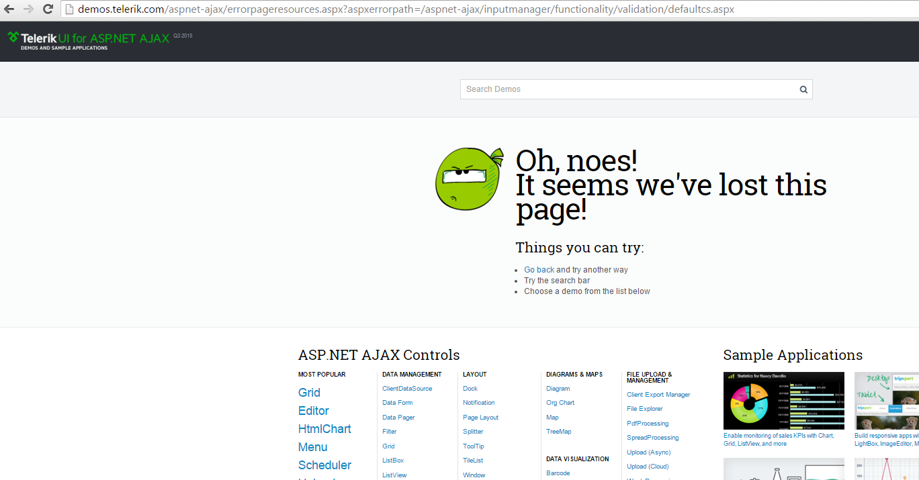

|  |  |
| --- | --- |
| **Bug ID** | **IP0002** |
| **Name** | [InputManager ] An Inappropriate Validation Massage is Displayed , when number greater than “UnitsInStock” is entered in quantity field |
| Description |  |
| Steps to reproduce | 1. Navigate to following URL:  <http://demos.telerik.com/aspnet-ajax/inputmanager/functionality/validation/defaultcs.aspx> 2. Left click on the icon “Edit” (looks like a pencil) 3. Type “-15” in Quantity field 4. Left click on the button “Update” (looks like a confirmation tick) |
| Actual behavior: | A validation message to be shown, “ Quantity cannot be null or **lower** than UnitsInStock ” |
| Expected behavior: | A validation message to be shown, like “ Quantity cannot be null or **greate**r than UnitsInStock |
| Priority |  |
| Severity | Low |

|  |  |
| --- | --- |
| **Bug ID** | **IP0003** |
| **Name** | [InputManager ] An InappropriateValidation Massage is Displayed , when negative number is entered in quantity field |
| Description |  |
| Steps to reproduce | 1. Navigate to following URL:  <http://demos.telerik.com/aspnet-ajax/inputmanager/functionality/validation/defaultcs.aspx> 2. Left click on the icon “Edit” (looks like a pencil) 3. Type “-12” in Quantity field 4. Left click on the button “Update” (looks like a confirmation tick) |
| Actual behavior: | A validation message to be shown, “Quantity cannot be negative number” |
| Expected behavior: | A validation message to be shown, like “ Quantity cannot be null or greater than UnitsInStock ” |
| Priority |  |
| Severity | Low |

|  |  |
| --- | --- |
| **Bug ID** | **IP0004** |
| **Name** | [InputManager No Validation Massage is Displayed , when string is entered in quantity field |
| Description |  |
| Steps to reproduce | 1. Navigate to following URL:  <http://demos.telerik.com/aspnet-ajax/inputmanager/functionality/validation/defaultcs.aspx> 2. Left click on the icon “Edit” (looks like a pencil) 3. Type “Hi” in Quantity field 4. Left click on the button “Update” (looks like a confirmation tick) |
| Actual behavior: | Edit form is still open Quantity input has red rectangle inside |
| Expected behavior: | A validation message to be shown, like “ Quantity can be only number lower than UnitsInStock” |
| Priority |  |
| Severity | Low |

|  |  |
| --- | --- |
| **Bug ID** | **IP0005** |
| **Name** | [InputManager ] No Validation Massage is Displayed , when number greater than 1 is entered in Discount Field |
| Description |  |
| Steps to reproduce | 1. Navigate to following URL:  <http://demos.telerik.com/aspnet-ajax/inputmanager/functionality/validation/defaultcs.aspx> 2. Left click on the icon “Edit” (looks like a pencil) 3. Enter “-15” in Discount field 4. Left click on the button “Update” (looks like a confirmation tick) |
| Actual behavior: | Edit form is closed, row is updated with Discount value 1 |
| Expected behavior: | A validation message to be shown, like Discount can be only a number between 0 and 1 |
| Priority |  |
| Severity | Low |

|  |  |
| --- | --- |
| **Bug ID** | **IP0006** |
| **Name** | [InputManager ] NoValidation Massage is Displayed , when negative number is entered |
| Description |  |
| Steps to reproduce | 1. Navigate to following URL:  <http://demos.telerik.com/aspnet-ajax/inputmanager/functionality/validation/defaultcs.aspx> 2. Left click on the icon “Edit” (looks like a pencil) 3. Enter “-9” in Quantity field 4. Left click on the button “Update” (looks like a confirmation tick) |
| Actual behavior: | Edit form is closed, row is updated with Discount value 0 |
| Expected behavior: | A validation message to be shown, like “Discount can be only a number between 0 and 1” |
| Priority |  |
| Severity | Low |

|  |  |
| --- | --- |
| **Bug ID** | **IP0007** |
| **Name** | [InputManager No Validation Massage is Displayed , when string is entered |
| Description |  |
| Steps to reproduce | 1. Navigate to following URL:  <http://demos.telerik.com/aspnet-ajax/inputmanager/functionality/validation/defaultcs.aspx> 2. Left click on the icon “Edit” (looks like a pencil) 3. Enter “Hi” in Quantity field 4. Left click on the button “Update” (looks like a confirmation tick) |
| Actual behavior: | Grid is refreshed, edit form is still open Quantity input has red rectangle inside |
| Expected behavior: | A validation message to be shown, like “Discount can be only a number between 0 and 1” |
| Priority |  |
| Severity | Low |

**Test Environment:**  
OS Name: Microsoft Windows 8.1 Enterprise

OS Type: 64-bit Operating System

Browser Name: Chrome

Browser Version: 47.0.2526.106 m